**Exercise 1:**

**Design a UI in Figma**

**AIM:**

To design a user-friendly and visually appealing user interface using Figma for a given application scenario.

**PROCEDURE:**

1. Open Figma and create a new design file.
2. Use frames to create screen layouts (e.g., mobile or desktop).
3. Add shapes (rectangles, circles) for buttons, cards, and input fields.
4. Apply fill colors, strokes, and shadows to style components.
5. Insert text elements for headings, labels, and buttons.
6. Align and group elements for clean layout.
7. Use prototyping tools to link screens (optional).
8. Preview the UI and make final adjustments.

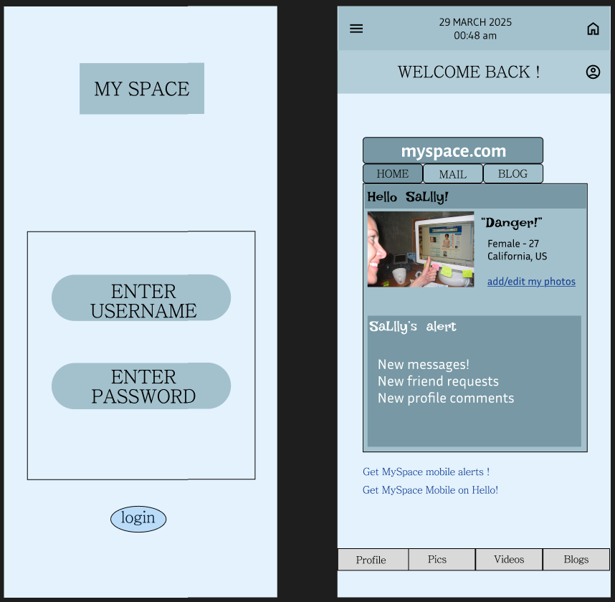**OUTPUT:**